Documentation – Heart-disease

Repository: <https://github.com/HuberNicolas/heart-disease>

Group: Kalvin Dobler, Nathalie Guttmann, Nicolas Huber

Information on the project:

Python Version: 3.8.5 (64-bit)

R Version: 4.0.4 (64-bit)

|  |  |
| --- | --- |
| Name of the folder | Description |
| 0 raw .data | Contains the raw data (incl. .md5 hashes) from the [source](https://archive.ics.uci.edu/ml/machine-learning-databases/heart-disease/). |
| 1 raw .csv | Contains the renamed .csv files and the formatter script (incl. .md5 hashes). |
| 2 formatted .csv | Contains the formatted .csv files without a header (incl. .md5 hashes). |
| data | Contains the datasets (incl. header) the analysis was run (incl. .md5 hashes). |
| logs | Contains the logfiles of the scripts. |
| plots | Contains the plots that were generated during the analysis. |
| rand_forest_feature_selection(25) | Contains the datasets (incl. header) after the random forest selection. These sets contain 25 features, that can “explain” 80% of the data. |

Information on datasets:

The following explanations are based on the heart-disease.NAMES file.

**Number of instances:**

* Cleveland: 303
* Hungarian: 294
* Switzerland: 123
* Long Beach VA: 200

**Number of attributes:** 76 (including the predicted attribute) See appendix for the complete list. (Missing Attribute Values: Several. Distinguished with value -9.0.)

“This database contains 76 attributes, but all published experiments refer to using a subset of 14 of them. In particular, the Cleveland database is the only one that has been used by ML researchers to this date.”

**Class distribution:** (Classtype (domain [0,4]) is referring to feature 58 “num”. It is an integer valued from 0 (absence of disease) to 4. In this project, the different levels for heart disease were taken in account during the analysis.

|  |  |  |  |  |  |  |
| --- | --- | --- | --- | --- | --- | --- |
| Database | Class = 0 | Class = 1 | Class = 2 | Class = 3 | Class = 4 | Total |
| Cleveland | 164 | 55 | 36 | 35 | 13 | 303 |
| Hungarian | 188 | 37 | 26 | 28 | 15 | 294 |
| Switzerland | 8 | 48 | 32 | 30 | 5 | 123 |
| Long Beach VA: | 51 | 56 | 41 | 42 | 10 | 200 |

Description of the process-pipeline:

**General:**

Note: For this data science project, **only the following. data files were used**:

|  |  |
| --- | --- |
| Filename | Md5-Hash |
| cleveland.data | 2388e97e27676171aa0a1c61bb4a3670 |
| hungarian.data | ce4a62b8de90d93d616ede3253239851 |
| long-beach-va.data | 381cee4b51b786623402929e2cc1ccf9 |
| switzerland.data | b2a3e9cc9c82dc0f8fa19bb851db495d |

These .data files were **not** used:

|  |  |
| --- | --- |
| Filename | Md5-Hash |
| new.data | 046bd9f619c20148b261b3e392c02591 |
| processed.cleveland.data | 2d91a8ff69cfd9616aa47b59d6f843db |
| processed.hungarian.data | 22e96bee155b5973568101c93b3705f6 |
| processed.switzerland.data | 9a87f7577310b3917730d06ba9349e20 |
| processed.va.data | 4249d03ca7711e84f4444768c9426170 |
| reprocessed.hungarian | 3698a53d41cccc2e4499e1273c055378 |

For the sake of completeness, nonetheless, we did include the whole folder.

Preparing the datasets:

First step: rename .data files (0 raw .data) to .csv (1 raw .csv).

Second step: format the .csv files via python script “formatter” (2 formatted .csv). This step was needed because the original data was badly formatted. The formatter.py formats the datasets, such that all features of one patient are one row and not scattered over multiple rows.

Third step: adding a header for the 76 features (data).

We finally get 4 files in our data folder:

|  |  |
| --- | --- |
| Filename | Md5-Hash |
| cleveland_76_header.csv | a67792681f83998d97e332bfb41efee0 |
| hungarian_76_header.csv | 6c86829818559cfb434126c61d5cb25c |
| long-beach-va_76_header.csv | 4dde4782acbbdac7b2198bb676fea13f |
| switzerland_76_header.csv | d4a1d37007107ee2fb73be8a4122bf32 |

Important note: At this moment, no entries were modified.

**Process of Visualization and Analyse**

The processing of the data was done in the following order. Pre-processing and (general) visualization, feature selection, reduction, and finally classification. We focus and start in this project on working with the whole dataset and not the pre-processed files, which only include a tiny subset of the features, to finally compare the locations with each other.

It is in general a good idea to start with some visualizations get a rough overview. In a second step, the selection is crucial, because 76 features go beyond the constraints of reasonable analysis. Using the RandomForestClassifier, 25 features were found to have the most impact on the data. For the dimensionality reduction the following approaches were used: t-SNE and UMAP as well as the autoencoders with R. Furthermore, a list of classification algorithms used for this project are listed below:

* Logistic Regression
* Naïve Bayes
* SVM (linear, poly (degree = 3) and kernel (rbf))
* KNN (nn = 5)
* Neural Networks

1. **PRE-PROCESSING & DATA VISUALIZATION**

Below is a summary of all plots; how they were generated, and which technique/method/model was used.

1. Visualization of Max heart rate vs age with the target variable “num” (1-4): Scatter Plot
2. Visualization of cholesterol level vs age with the target variable “num” (1-4): Scatter Plot
3. Visualization of blood pressure vs chest pain: Box Plot
4. Visualization of correlation between features and target variable “num” (1-4): Bar Plot (corrwith)
5. Visualization of correlation between features and target variable “num” (1-4): Heatmap (.corr)
6. Visualization of blood pressure vs age with the target variable: LMplot (.lmplot : scatterplot with an optional overlaid regression line)
7. Visualization of heart rate vs age with the target variable: LMplot (.lmplot : scatterplot with an optional overlaid regression line)
8. Visualization of distribution of age according to the presence of heart disease: KDEplot (.kdeplot : represents the data using a continuous probability density curve)
9. Visualization of comparison between the distribution of the disease according to age and sex: Bar Plot (.groupby)
10. **FEATURE SELECTION**
11. Visualization of feature importance: Bar Plot (RandomForestClassifier) => saved under / rand_forest_feature_selection (25)
12. **DIMENSIONALITY REDUCTION & VISUALISATION**
13. Visualization of feature reduction for different perplexities: Scatter Plot (TSNE)
14. Visualization of feature reduction: Scatter Plot (UMAP)
15. **CLASSIFICATION**
16. Visualization of logistic regression: Heatmap (LogisticRegression)
17. Visualization of performance of logistic regression: ROC plot + AUC result; Print accuracy: (metrices.accuracy_score)
18. Visualization of naïve Bayes: Heatmap (GaussianNB)
19. Visualization of performance of naïve Bayes: ROC plot + AUC result; Print accuracy: (metrices.roc_auc_score)
20. Visualization of performance of SVM (linear kernel): ROC plot + AUC result; Print accuracy: (metrices.accuracy_score)
21. Visualization of performance of SVM (poly (d=3) kernel): ROC plot + AUC result; Print accuracy: (metrices.accuracy_score)
22. Visualization of performance of SVM (rbf kernel): ROC plot + AUC result; Print accuracy: (metrices.accuracy_score)
23. Visualization of SVM (linear, poly (d=3) and rbf kernel): Heatmap (svm.SVC(kernel = TYPE))
24. Visualization of KNN: KNeighborsClassifier(n_neighbors = 5, algo = “ball_tree”) ; Print accuracy: (accuracy_score)
25. Visualization of performance of KNN: ROC + plot; Print cross validation: (cross_val_score)
26. Visualization of performance of simple neural Network: model = Sequential(), model.fit()
27. **ACCURACIES OF CLASSIFICATION METHODS**

Summary of the scripts (and their log-files) of the accuracy in the form of a table.



1. **FEATURES SELECTION**

Below are listed the top five most important features for each location as well as their result for the Autoencoder.

**Cleveland :**

Laddist – “distal left anterior descending artery” seems to be one of the most important features. Indeed, it is part of the left main coronary artery (LAD), supplying more than half of the blood to the heart.

Thal – “exercise thallium scintigraphy” is a diagnostic method in nuclear medicine that enables the visualization of well-perfused and vital tissue of myocardium by means of 201thallium absorbed by its cells. This method is used to evaluate the character of soft tissue lesions. In this dataset the feature is divided into three categories from normal to defect.

Om1 – “first obtuse marginal branch” is also an important vessel that is part of the left main coronary artery (LAD).

Ca – “number of major vessels”.

Rcaprox – “proximal right coronary artery” is part of the right coronary artery (RCA).

Autoencoders

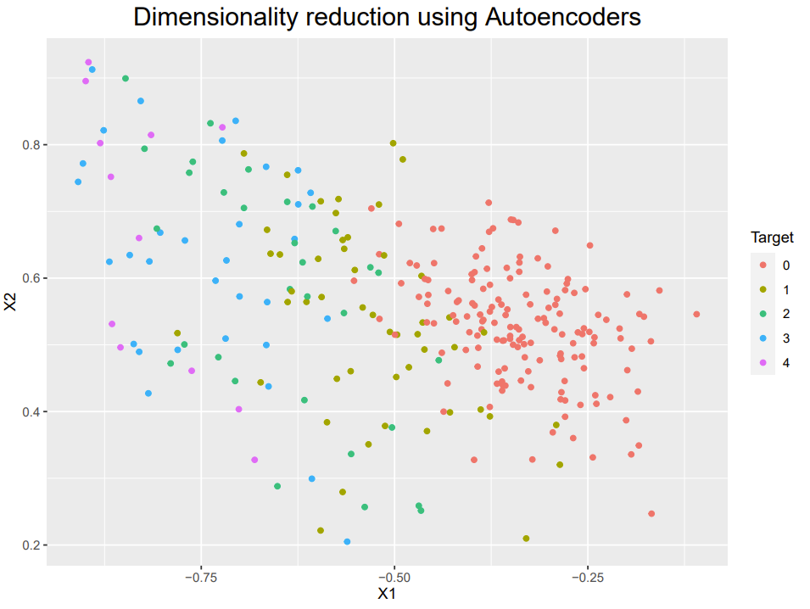

**Hungary :**

Cp – “chest pain” seems to be selected as the most important feature. It is divided into four categories: type: 1 = typical angina; 2 = atypical angina; 3 = non-angina pain; 4 = asymptomatic.

Painexer – “pain provoked by exertion”. It is divided into two categories: 1 if the patient felt pain during effort, 0 otherwise.

Oldpeak – “exercise-induced ST depression relative to rest” is an exercise electrocardiography test to evaluate whether the trace in the ST segment is abnormally low below the baseline which is often a sign of myocardial ischemia.

Lvx4 – not used / not described / no information regarding this feature.

Exang – “Exercise-induced angina”. It is divided into two categories: 1:yes, 0: otherwise.

* Autoencoders

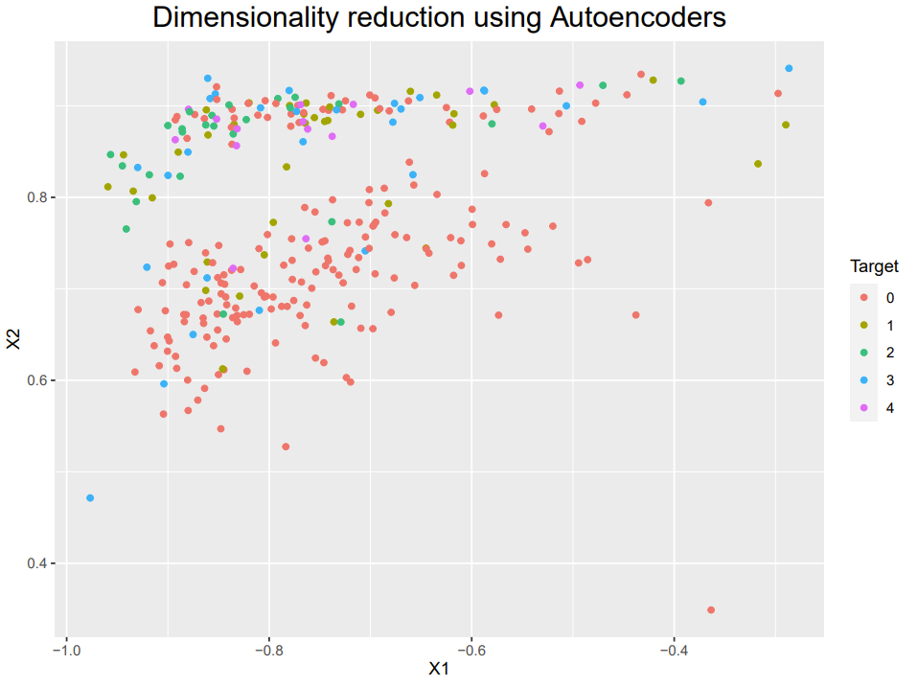

**Switzerland :**

Cxmain – “circumflex”. It is another vessel that is part of the left main coronary artery (LAD),

ID – identification of patient, not relevant.

Thalach – “maximum heart rate achieved” refers to the maximum heart rate achieved during thalium stress test. At first sight, we might suppose that the maximum heart rate is lower for those diagnosed with heart diseases. Indeed, it seems logical to assume that a higher rate indicates a satisfactory heart condition since it managed to increase its rate to such a level during the stress test.

Tpeakbps – “peak exercise systolic blood pressure”.

Age – “age of the patients”.

* Autoencoders

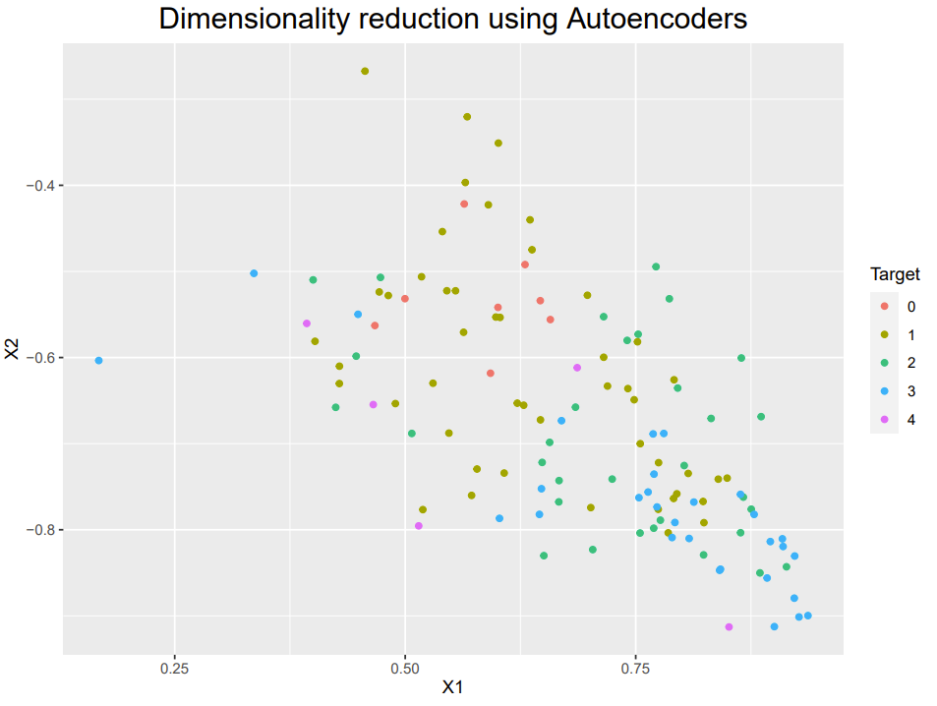

**Long Beach :**

Rcaprox – “proximal right coronary artery” is part of the right coronary artery (RCA).

Ladprox – “proximal left anterior descending artery” which is part of LAD.

Cxmain – “circumflex”. It is another vessel that is part of the LAD.

ID – not relevant.

Cday – “day of cardiac catheterization”. Not relevant.

* Autoencoders

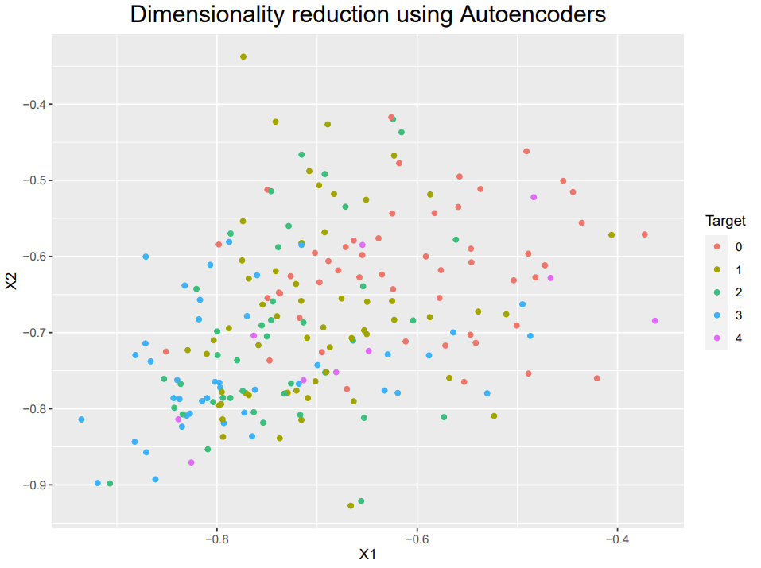

**Conclusion:**

The following 3 questions were formulated in our proposal:

“Are some parameters more likely to be associated with heart disease?”

“Can we find any differences between the different locations?”

“Can different levels of a heart disease be differentiated from each other?”

With the random forest method, 25 features were selected that could explain about 80% of the data. A list with the top five most important features for each location taking in account the different class distributions for a heart disease was listed from page 5-8. Of note is that no irrelevant features for the risk of CVDs were excluded from the analysis (e.g. ID in Switzerland and Vancouver). Interestingly, the ID parameter was classified as important for predicting the outcome by the algorithm. This shows the discrepancy between an algorithm and medical application for defining important risk factors for a CVDs.

Regarding the prediction of heart disease, this project is sobering. For some datasets, the prediction was not good and a variation in the accuracy regarding the different classification methods for predicting risk factors was observed (chapter V).

Differences of selection of risk factors for predicting heart disease were shown between locations (pages 5-8). Furthermore, additional minor differences between locations were observed when performing an Exploratory Data Analysis, for instance, for the distribution of age and the type of disease. One reason could be that those locations showed a similar socio-demographic structure in 1998.

Lastly, differences between class conditions for heart disease were difficult to discern as results showed no clear clustering for each class conditions when using different classification methods.

**Limitation and Outlook:**

In retrospect, were now able to reflect on the project and to discuss improvements that could be made on further projects. We start with the limitation:

* The dataset was a bit outdated. The conditions have changed since 1998.
* The Swiss dataset was highly unbalanced (very few 0’s and 4’s in the “num”). Consequently, ROC-scores for some classification methods could not be obtained. In addition, the Swiss dataset has no information on the cholesterol level (default 0), which means no second scatter plot could be to be plotted. Overall, the Swiss data set was not very suitable for this analysis. The above-mentioned difficulties were (amongst other things) responsible for the low model accuracy.
* Some features (incl. class distributions of heart disease) were not described. We do not know, how these features were collected or measured. Also, some features are missing in datasets, for instance, cholesterol in the Swiss dataset.

Having said that, we also record some thoughts for further improvements:

* We can fine-tune the model parameters for each dataset to achieve higher accuracy. That means the pipeline may look different and it may not be possible anymore to compare different regions, but the accuracy might increase.
* Expanding the choice of the features to maybe 50 would be interesting. Also, maybe a reduction could gain more insights.
* Excluding features thought to be irrelevant.
* Working with a current dataset on heart disease and then compare the results between old datasets and new ones. What did change, what stayed the same?

**Appendix:**

Complete attribute documentation:

1. id: patient identification number
2. ccf: social security number (I replaced this with a dummy value of 0)
3. age: age in years
4. sex: sex (1 = male; 0 = female)
5. painloc: chest pain location (1 = substernal; 0 = otherwise)
6. painexer (1 = provoked by exertion; 0 = otherwise)
7. relrest (1 = relieved after rest; 0 = otherwise)
8. pncaden (sum of 5, 6, and 7)
9. cp: chest pain type
   * Value 1: typical angina
   * Value 2: atypical angina
   * Value 3: non-anginal pain
   * Value 4: asymptomatic
10. trestbps: resting blood pressure (in mm Hg on admission to the hospital)
11. htn
12. chol: serum cholestoral in mg/dl
13. smoke: I believe this is 1 = yes; 0 = no (is or is not a smoker)
14. cigs (cigarettes per day)
15. years (number of years as a smoker)
16. fbs: (fasting blood sugar > 120 mg/dl) (1 = true; 0 = false)
17. dm (1 = history of diabetes; 0 = no such history)
18. famhist: family history of coronary artery disease (1 = yes; 0 = no)
19. restecg: resting electrocardiographic results
    * Value 0: normal
    * Value 1: having ST-T wave abnormality (T wave inversions and/or ST elevation or depression of > 0.05 mV)
    * Value 2: showing probable or definite left ventricular hypertrophy by Estes' criteria
20. ekgmo (month of exercise ECG reading)
21. ekgday(day of exercise ECG reading)
22. ekgyr (year of exercise ECG reading)
23. dig (digitalis used furing exercise ECG: 1 = yes; 0 = no)
24. prop (Beta blocker used during exercise ECG: 1 = yes; 0 = no)
25. nitr (nitrates used during exercise ECG: 1 = yes; 0 = no)
26. pro (calcium channel blocker used during exercise ECG: 1 = yes; 0 = no)
27. diuretic (diuretic used used during exercise ECG: 1 = yes; 0 = no)
28. proto: exercise protocol
    * 1 = Bruce
    * 2 = Kottus
    * 3 = McHenry
    * 4 = fast Balke
    * 5 = Balke
    * 6 = Noughton
    * 7 = bike 150 kpa min/min (Not sure if "kpa min/min" is what was written!)
    * 8 = bike 125 kpa min/min
    * 9 = bike 100 kpa min/min
    * 10 = bike 75 kpa min/min
    * 11 = bike 50 kpa min/min
    * 12 = arm ergometer
29. thaldur: duration of exercise test in minutes
30. thaltime: time when ST measure depression was noted
31. met: mets achieved
32. thalach: maximum heart rate achieved
33. thalrest: resting heart rate
34. tpeakbps: peak exercise blood pressure (first of 2 parts)
35. tpeakbpd: peak exercise blood pressure (second of 2 parts)
36. dummy
37. trestbpd: resting blood pressure
38. exang: exercise induced angina (1 = yes; 0 = no)
39. xhypo: (1 = yes; 0 = no)
40. oldpeak = ST depression induced by exercise relative to rest
41. slope: the slope of the peak exercise ST segment
    * Value 1: upsloping
    * Value 2: flat
    * Value 3: downsloping
42. rldv5: height at rest
43. rldv5e: height at peak exercise
44. ca: number of major vessels (0-3) colored by flourosopy
45. restckm: irrelevant
46. exerckm: irrelevant
47. restef: rest raidonuclid (sp?) ejection fraction
48. restwm: rest wall (sp?) motion abnormality
    * 0 = none
    * 1 = mild or moderate
    * 2 = moderate or severe
    * 3 = akinesis or dyskmem (sp?)
49. exeref: exercise radinalid (sp?) ejection fraction
50. exerwm: exercise wall (sp?) motion
51. thal: 3 = normal; 6 = fixed defect; 7 = reversable defect
52. thalsev: not used
53. thalpul: not used
54. earlobe: not used
55. cmo: month of cardiac cath (sp?) (perhaps "call")
56. cday: day of cardiac cath (sp?)
57. cyr: year of cardiac cath (sp?)
58. num: diagnosis of heart disease (angiographic disease status)
    * Value 0: < 50% diameter narrowing
    * Value 1: > 50% diameter narrowing

(in any major vessel: attributes 59 through 68 are vessels)

1. lmt
2. ladprox
3. laddist
4. diag
5. cxmain
6. ramus
7. om1
8. om2
9. rcaprox
10. rcadist
11. lvx1: not used
12. lvx2: not used
13. lvx3: not used
14. lvx4: not used
15. lvf: not used
16. cathef: not used
17. junk: not used
18. name: last name of patient (I replaced this with the dummy string "name")